Expt. no: 6 Date:

Creating a new footprint for IC LM741 and assigning a 3D model using KiCAD 8

Objective:
- To create a new footprint for IC LM741
- To assign this footprint to the IC LM741 symbol.
- To assign an existing 3D model to this footprint.

Software: KiCAD 8

Procedure:
- Choose the datasheet for IC LM741. Refer to the physical dimensions of the IC Mechanical Data section.
- Create a new footprint library:
  - Open the Footprint Editor from the Project Manager.
  - Click File → New Library and select Project. Name the new library and save it in the project directory.
  - The empty new library is now selected in the Libraries pane at left and has been automatically added to the project library table.
- Create a new footprint:
  - With the new library selected in the Libraries pane, create a new footprint (File → New Footprint…​). Set the name of the footprint and set the type to Through Hole.
  - Note that in KiCad’s default coordinate system, the positive Y-axis is oriented downwards.
    - According to the dimensions of the IC body mentioned in the datasheet, calculate the X and Y coordinates of the top-left corner and bottom-right corner of the body and note them down. Draw the outline of the body using the F. Silkscreen layer and the rectangle tool.
    - According to the spacing between the pins mentioned in the datasheet, calculate the X and Y coordinates of the center of soldering pads of each of the pins of the IC LM741. Note them down.
  - Use the ‘Add a pad’ tool in the right toolbar to place a pad. Press Escape to exit the pad tool, then double-click on the pad to edit its properties.
    - Edit the pad number according to the datasheet and enter the X and Y coordinates as per calculations.
    - Set the hole diameter, and the pad diameter to provide a sufficient annular ring.
    - Repeat for all pins as per the datasheet.
  - Draw the courtyard layer around the footprint that avoids overlapping of footprints while making the PCB layout.
  - Click on File → Footprint Properties… Enter the Value as IC LM741 appended with your initials, insert the URL of the datasheet, and write the description and keywords of the device as necessary.
- Perform Design rules check (DRC), fix errors, and repeat.
- Associate this footprint to the symbol created in the previous experiment:
  - Open the Symbol Editor from the Project Manager.
  - Select the Symbol library that you created.
  - Select the symbol from that library that you created.
  - Click on File → Symbol Properties… and under Footprint, click on the library symbol, browse to the footprint library and footprint that you created, then select it. Click OK.
  - Perform the Electrical Rules Check (ERC), fix errors, repeat.
- Assign an existing 3D model to the footprint:
  - Open the Footprint Editor, Select your Footprint library, and open your footprint. Click on File → Footprint Properties…
  - Click on the 3D Models tab.
  - Click on the folder symbol and browse to the ‘Package_DIP.3dshapes’ folder.
  - In the list of 3D models that appear, scroll down to the DIP-8_W7.62mm.step model. Double-click to select it.
  - Change the X, Y scale and X, Y offset to fit the model to the footprint well. Verify the front and back sides of the board for the placement of the 3D model. The pins should correctly pass through the pad holes.
  - Click ok and save the footprint.
Calculations:
- Body length from datasheet: 9.08mm
- Body width from datasheet: 9.08mm
- KiCAD Footprint Body Rectangle Top-Left (X, Y) Coordinates: (-4.54,-4.54)
- KiCAD Footprint Body Rectangle Bottom-Right (X, Y) Coordinates:(4.54,4.54)
- Vertical Spacing between pins from datasheet: 2mm
- Horizontal Spacing between pins from datasheet: 9.08mm
- Location of the center of soldering pads:
Pin No. | (X, Y) Coordinate | Pin No. | (X, Y) Coordinate
1 | -4.54,-3 | 8 | 4.54,-3
2 | -4.54,-1 | 7 | 4.54,-1
3 | -4.54,1 | 6 | 4.54,1
4 | -4.54,3 | 5 | 4.54,3
Table 6.1 Location of soldering pads
Implementation:

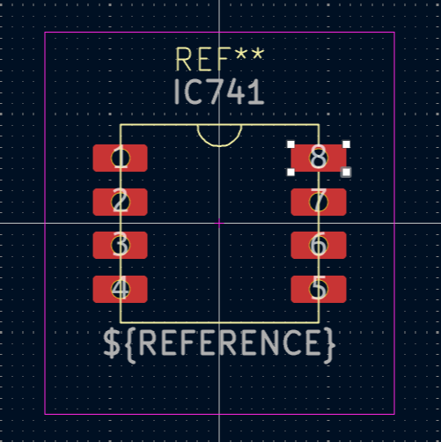
Fig. 6.1 Footprint created

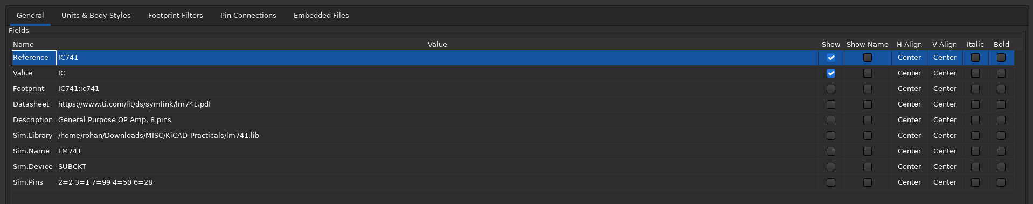
Fig. 6.2 Symbol Properties with Footprint assigned

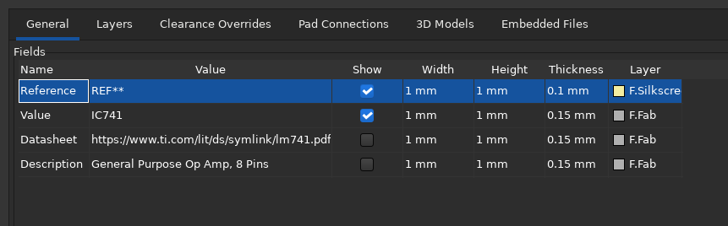
Fig. 6.3 Footprint properties

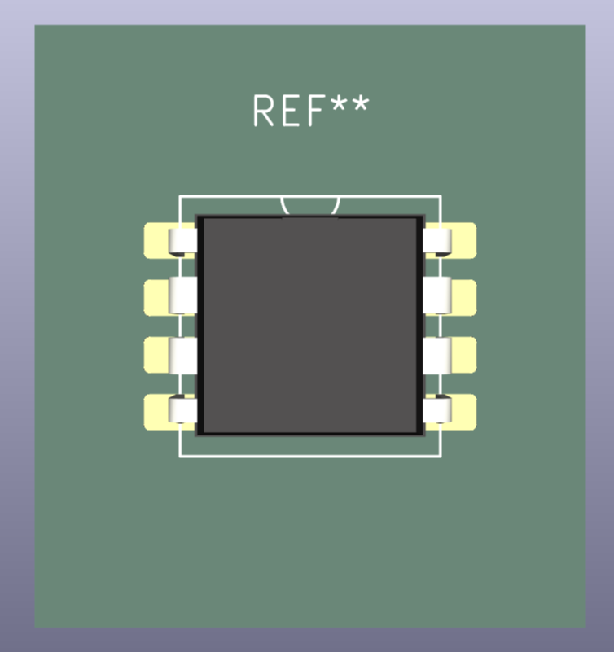
Fig. 6.3 Component-side view of the 3d model


Fig. 6.4 Solder-side view of the 3d model

Challenges: 1) One of the main challenges I encountered was that the file was not getting added to the list of libraries. I discovered that I needed to manually add them by going to “Manage Footprint Libraries” to incorporate either a global library or a project-specific library.
2) Another difficulty I faced was properly defining the coordinates that matched the IC chip specifications. I eventually realized that I needed to set the left-hand side coordinates to (0,0) while the right-hand side coordinates should be (9.08, 9.08). Since the IC chip has dimensions of 9.08mm by 9.08mm, centering the footprint and assigning the 3D model became much simpler after this adjustment.

Conclusion: The following objectives were successfully achieved:
- Creation of a new footprint for IC LM741
- Assignment of this footprint to the IC LM741 symbol
- Assignment of an existing 3D model to this footprint

